**Part B: Corporate Bond Exercise**

**Investment Grade**



By SRCH i first get all bonds over BBB- rating, then I filtered the columns. I compare their yield to maturities considering also their maturities, that, earlier to have the principal back is better. I generally use middle term bonds but choose some longer period bonds considering they dont have too much default risk. My latest maturity is on 2048.

**High Yield**



Here, i filtered just the bonds with over 50 yield to maturity,then i picked between them who has not too bad creditrankings. I also considered maturitiy types to not choose sinkable assets, and not with prices that is too low than their par value. I considered their default risk anyway but my bonds are not all from same industry or even country, so I expect just few of them can go default, and even just one survival will averagly double its principal, respectivelt in a short run (max is just 2025 and 3 of them is 2018. One of them will pay back the principal in two weeks with more than 10% capital profit for such period.

My average annual return is around 81.4, till my first maturity date (25.04.2018), and considering non of my corporation will not go bankruptcy. So real estimation should be much more down but I couldn’t manage to use create portfolio tools to make scenario analisis or annual returns for different years or to see an estiamted average return over all portfolios maturity.

The Barbell strategy is a method that tries to benefit form the bests of both secure world and high yield world. The risk of high yield bonds will be distibuted to many mixed bonds from also high credit mark bonds. So we will be far to middle return middle credit points, but choose from margins.*In fact it was my strategy for picking bonds with so high credit mark and so high returns together.*

**Part C: Treasury Bond Exercise**

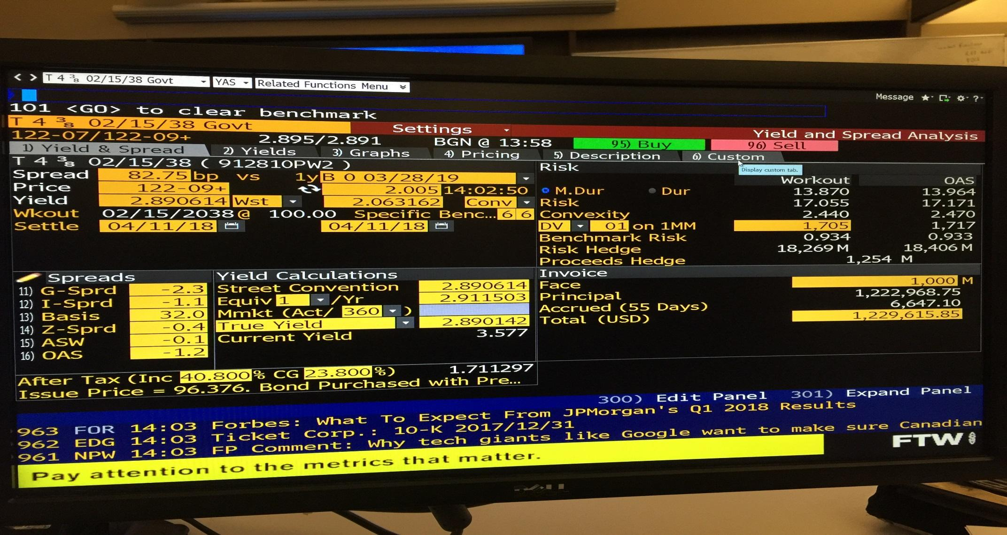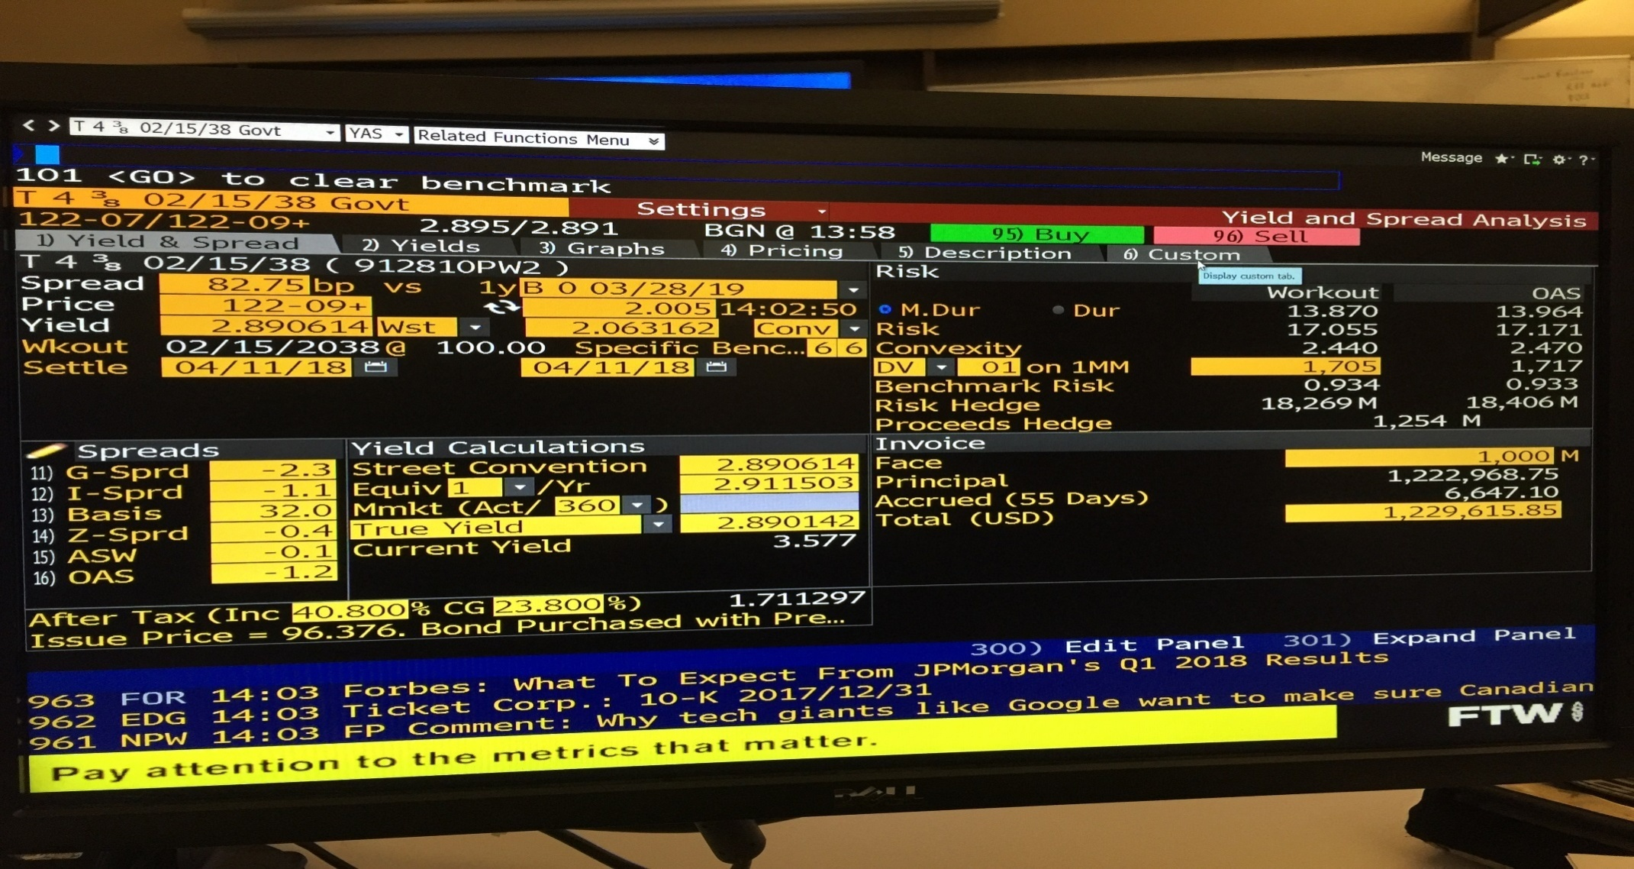

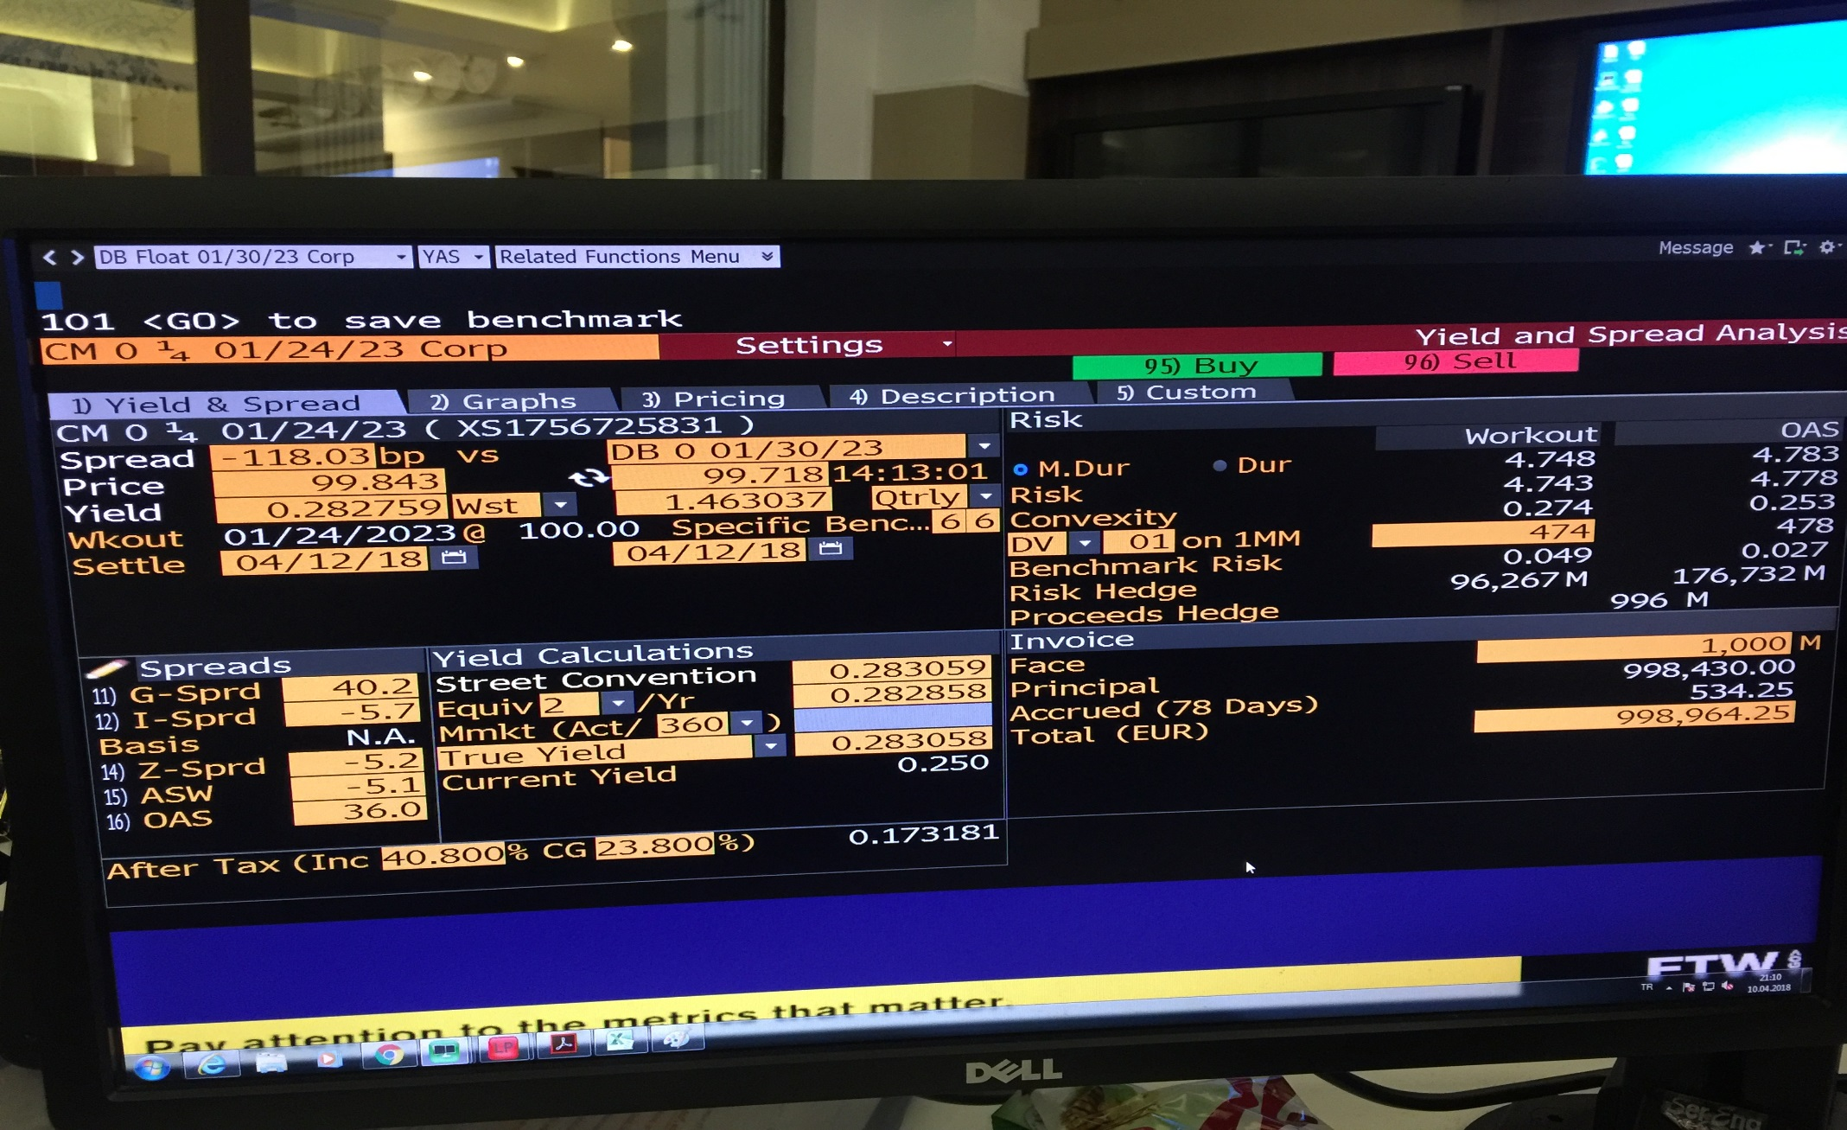**Part D: Bond RatingExercise**

**A-**

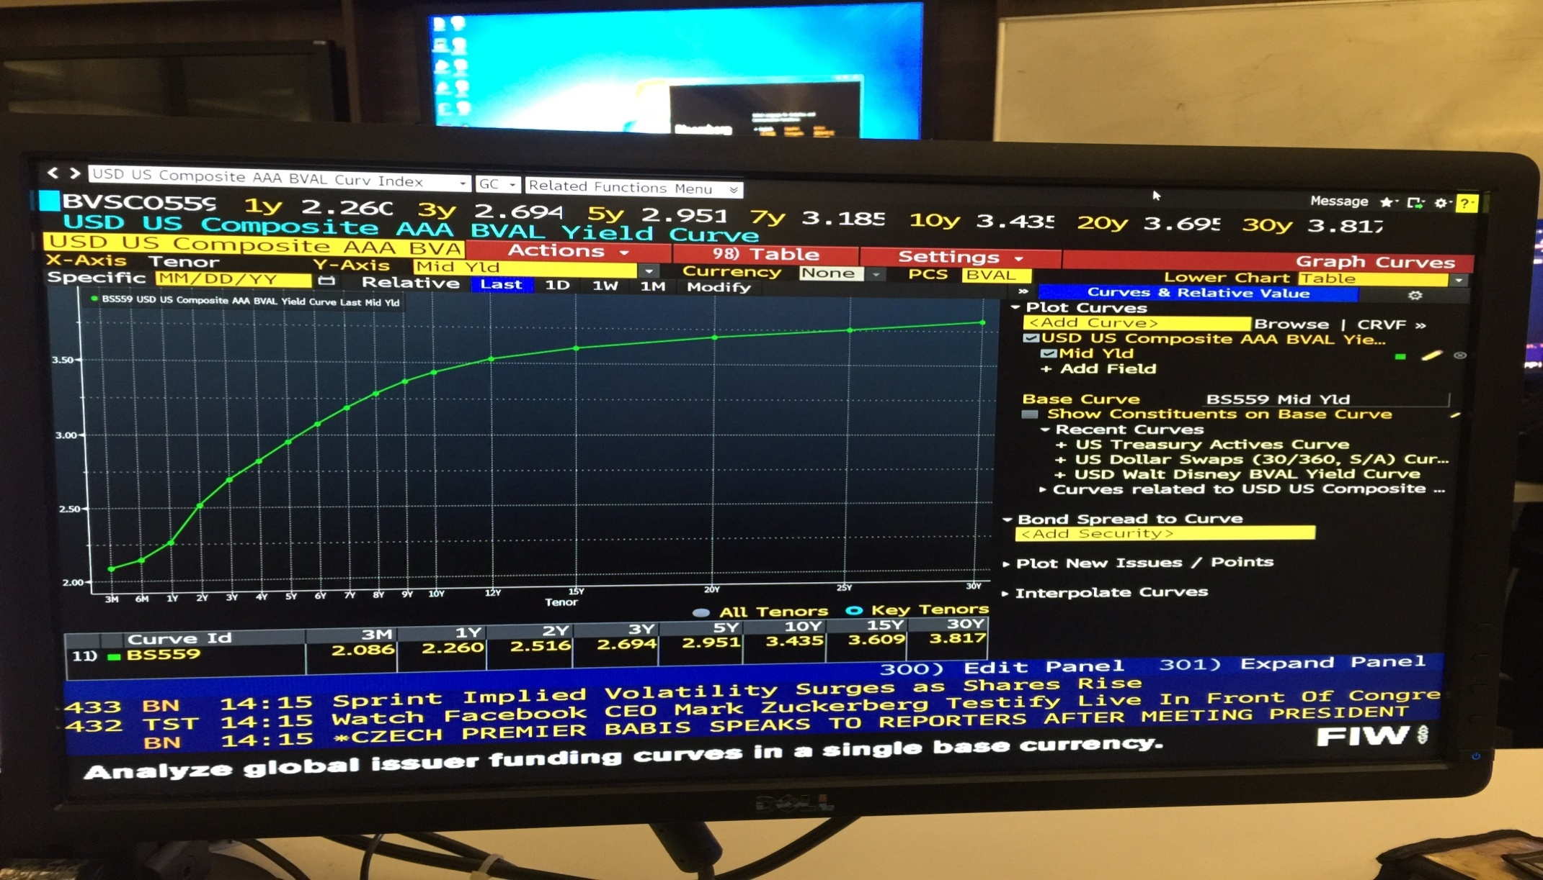

**B-**

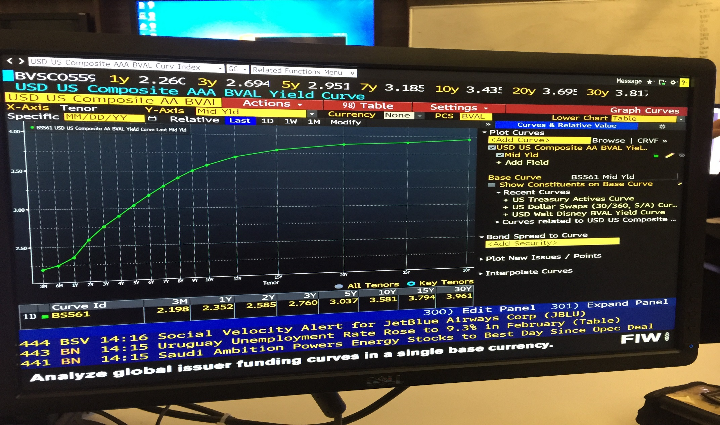

**C-**

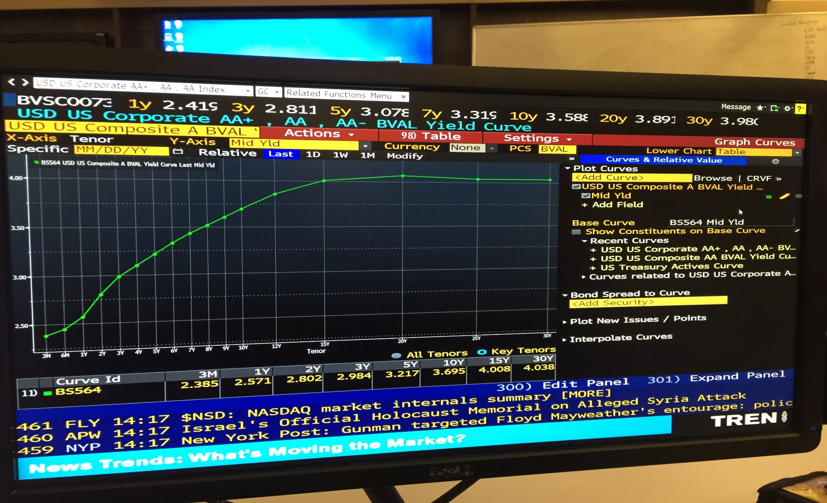

**D-**

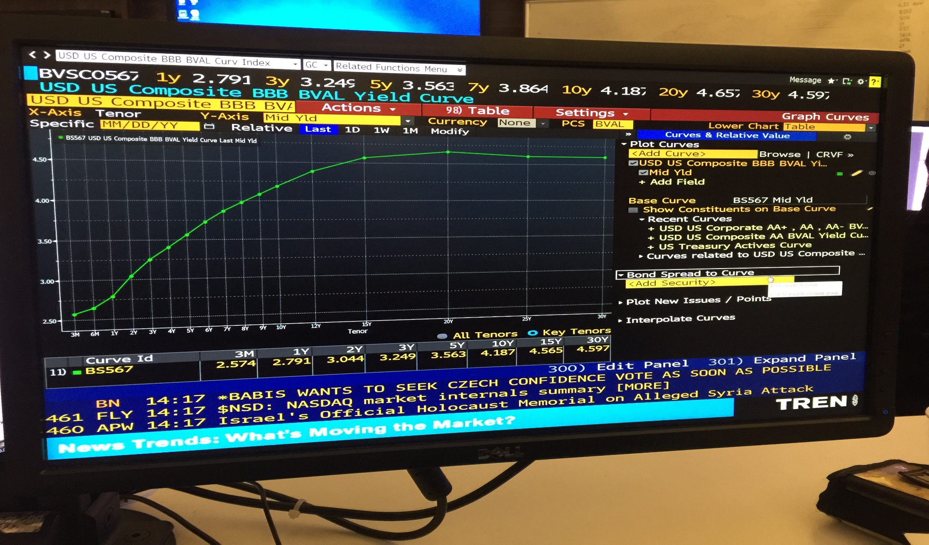

**E-**

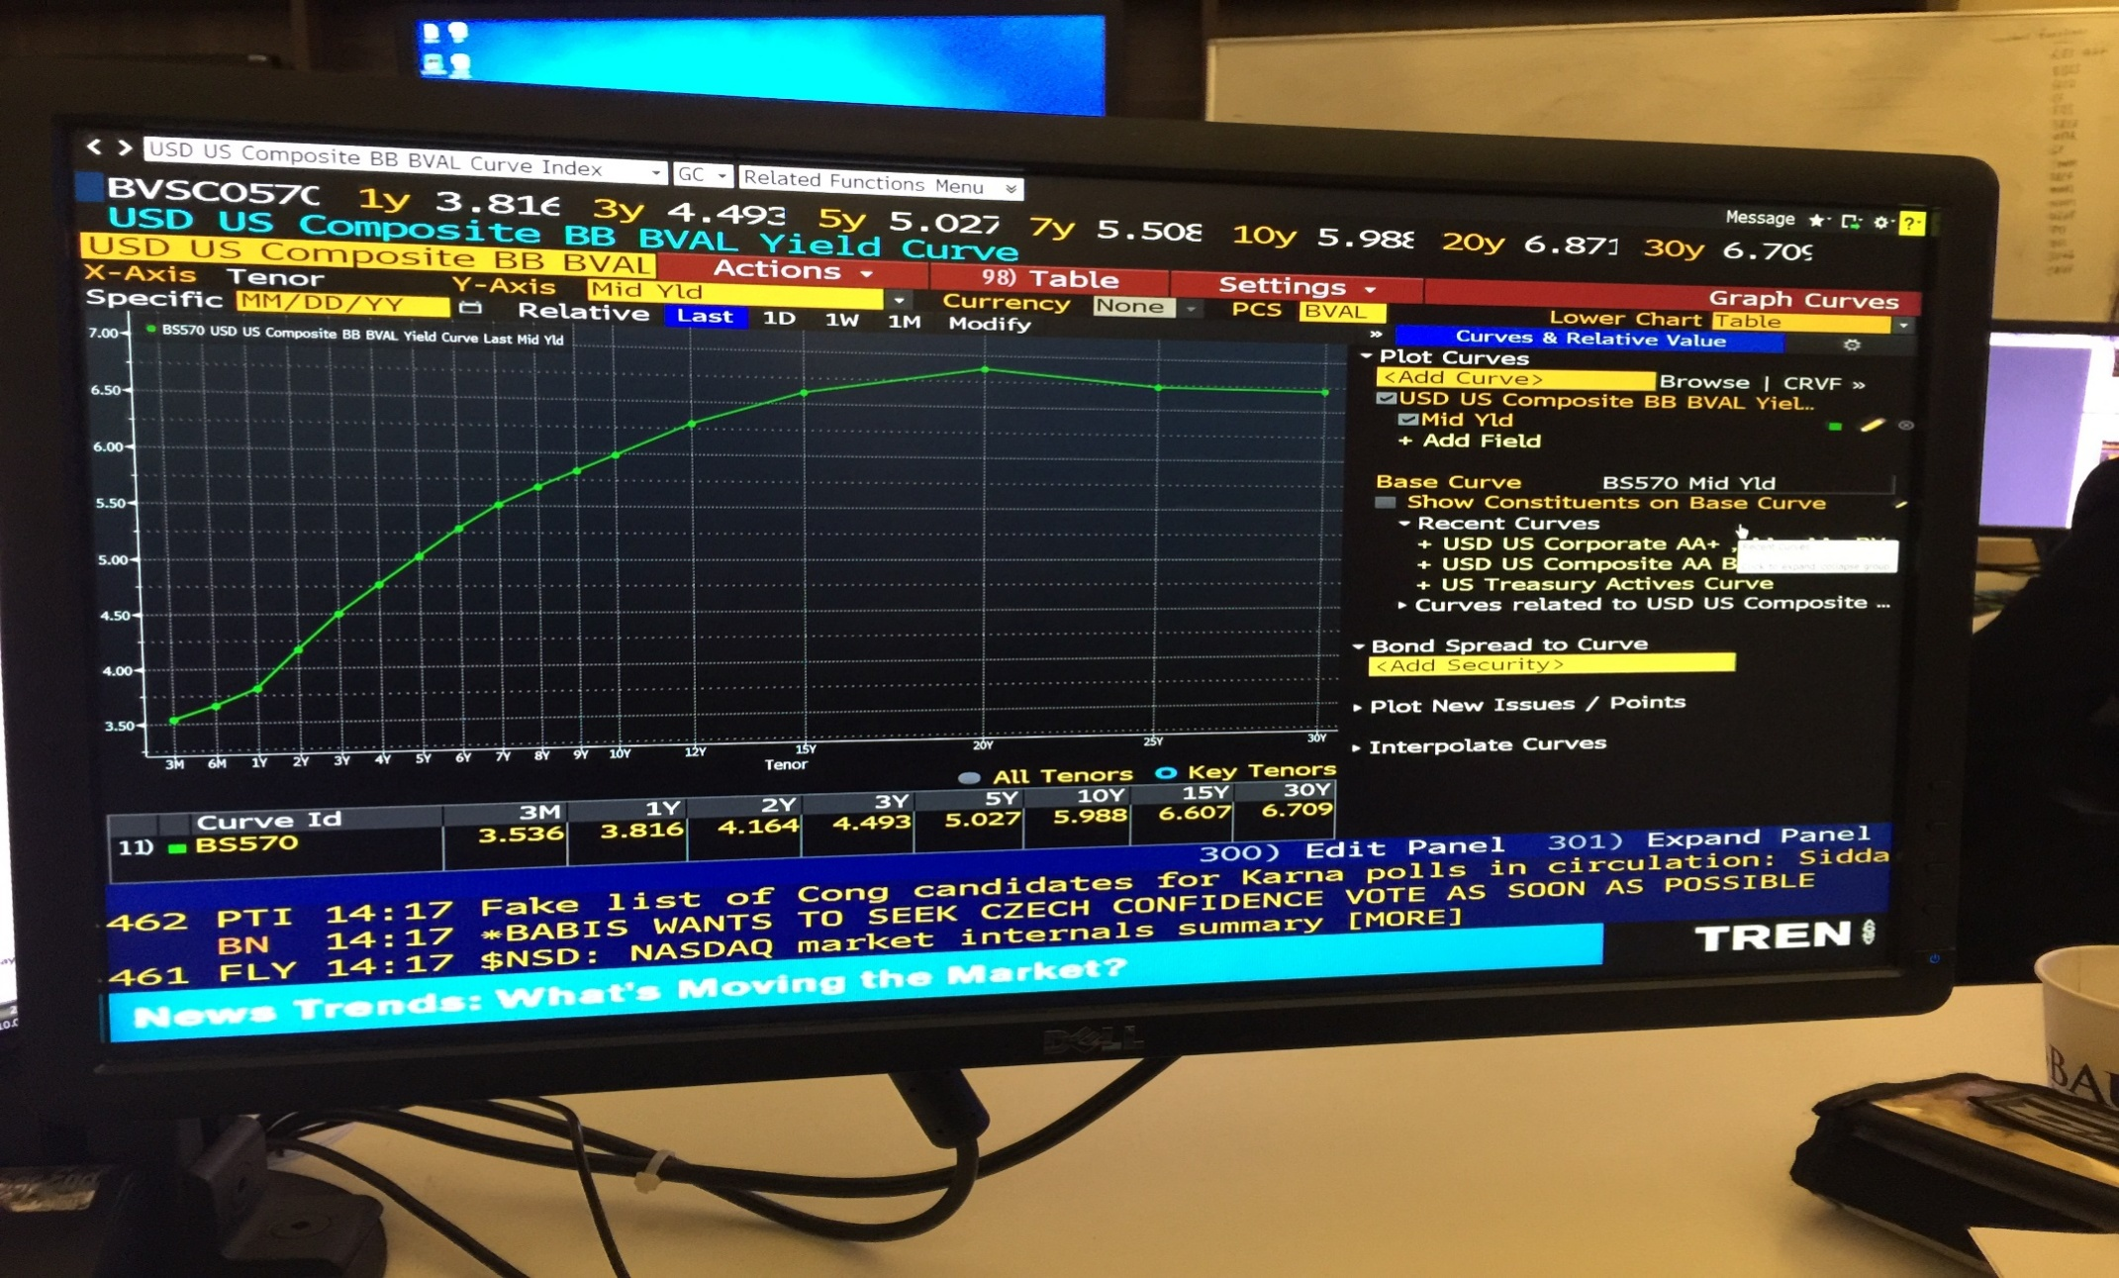

**Part E: GraphCurveSurface**

1. **What do you think this visual is showing us?**

**Hihger maturities gives higher return always since 2016( I couldn’t go more back)**

**It is clear that yields are increased in all maturities since 2016 till today.**

**There is a drammatical increase in November, 2016. I don’t see a recession risk since yield curves never has never negative slope for any maturity.**

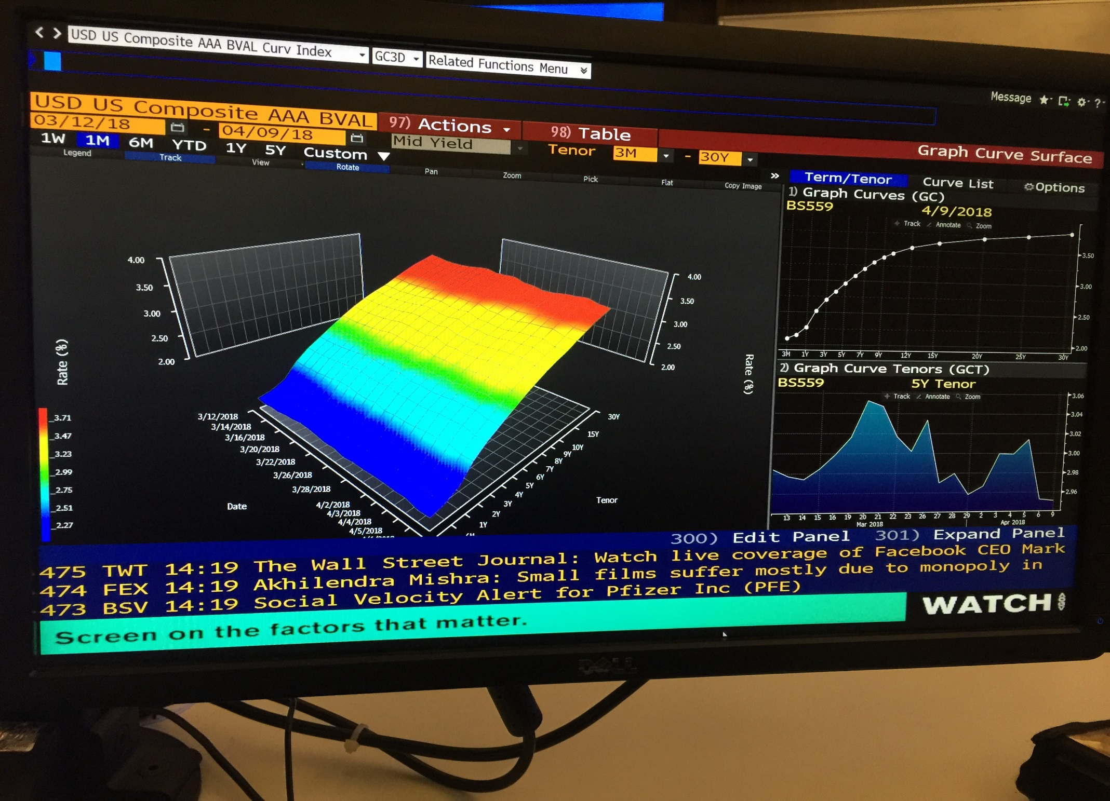

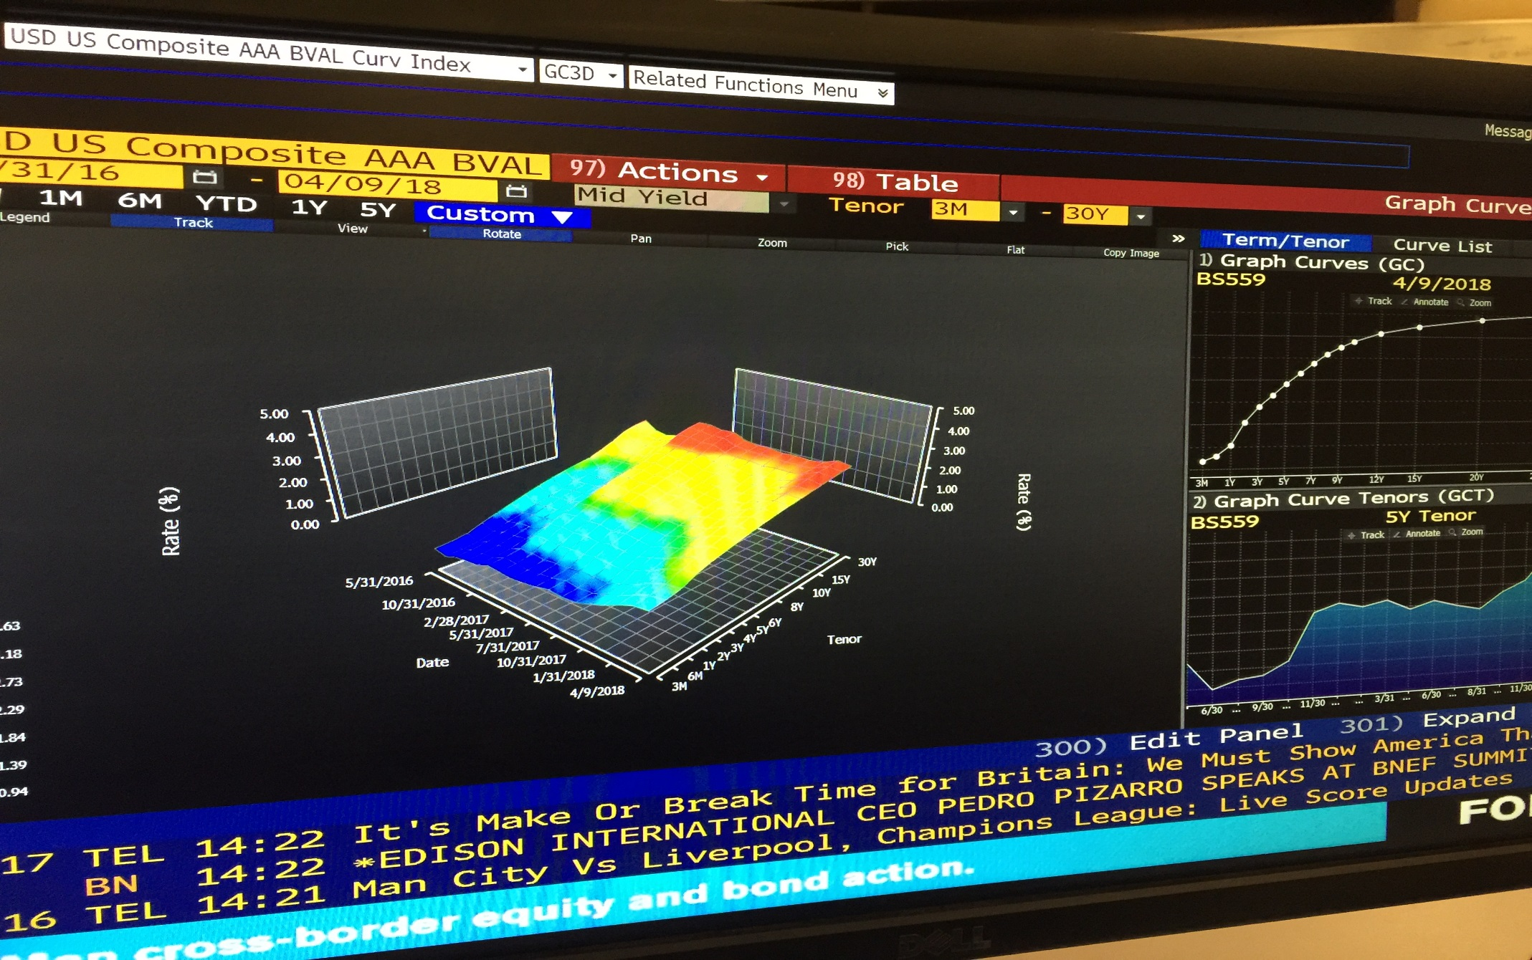

**Part F: Confidence Index Exercise**

**a. One-Year maturities.**

0.0809

**b. Five-Year Maturities.**

0.8281

**c. Ten-Year Maturities.**

0.8204

**d. Suppose this measure is gradually rising. Explain why this might be viewed as a positive leading indicator of the economy.**

While the investors smells risk in the future, sure first they would be far from not too much secure assets, especially for long run (as I did in High-Yield portfolio selection). Or they will demand higher and higher risk premiums – cheaper prices,to buy them.

In such situation, we would see two above mentioned curves would diverge, through higher maturies, which means our ratio would decrease.

So I can think, while this ratio is decreasing by longer matury, there is risk-off ambient in general, for investors: A positive indicator. Even leading, because the it reflects all investors long-run expectation calculations as just one ratio of today.

**Part G: Feedback (1 point)** – Please provide feedback for at least one of the three options below:

1. In youropinion, what is something about this IC that I should change?

I sometimes needed more hint, and couldnt be sure to understand some parameters like expiration. I had some troubles to chose true indicator between similar ones.

1. In your opinion, what was your favorite part about this IC?

I beileve i learned usefull tips to filter or search between bonds, even i may be couldnt chose the best bonds to invest, i can say technically i learned how to basicly compare the bonds.